**Weight Bearing Precautions**

**WBAT:**

* Put as much as weight on the lower extremity ( leg ) as possible if it hurts put more weight on the opposite leg.

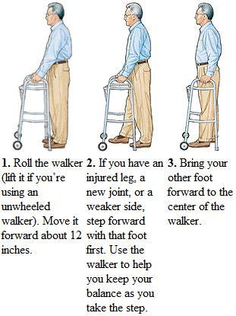

**TTWB**

* Toe touch weight bearing- put the weight on the toes only
* 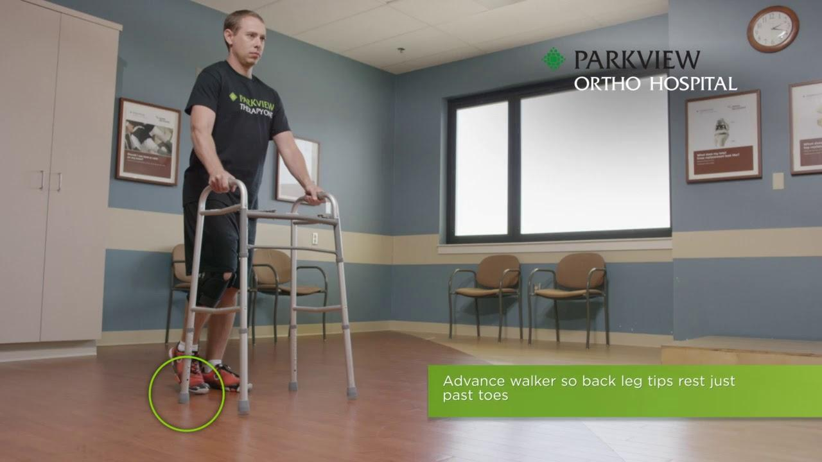

**NWB: non weight bearing**

* 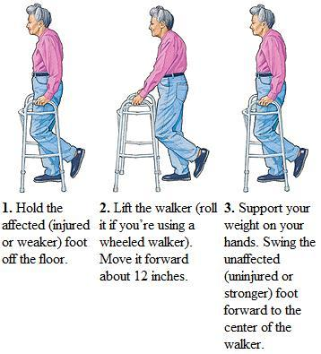

FWB: full weight bearing

* Put full weight through the extremities