**Physical Therapy Evaluation**

1. **Transfers/Bed mobility**

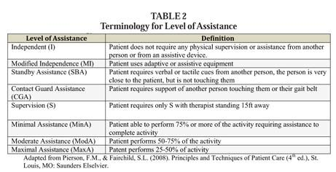

1. **Assess the patients tone**

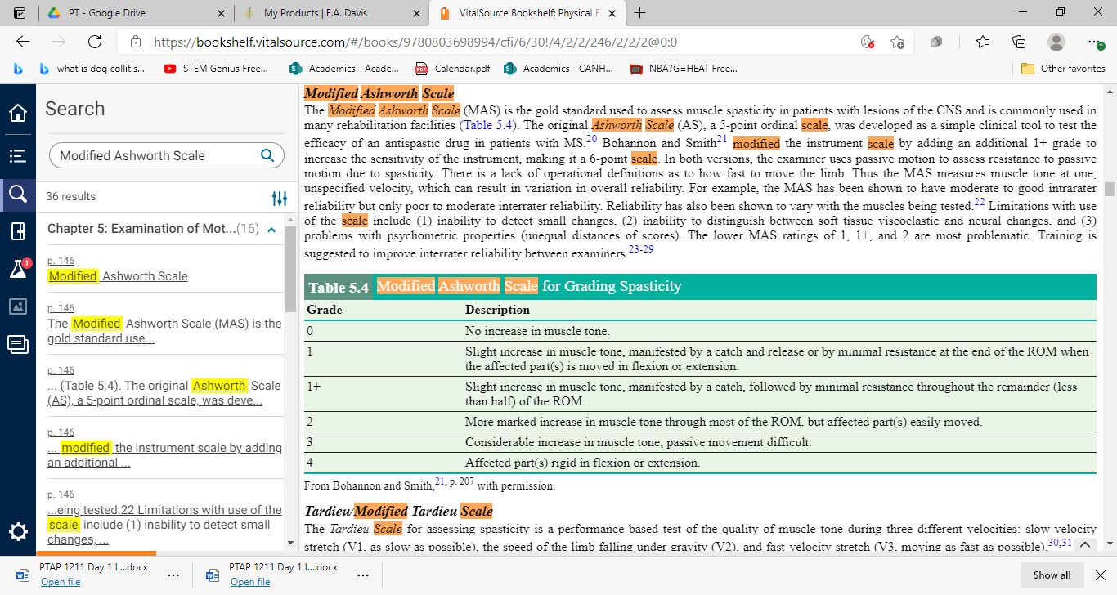

1. **Motor Recovery Stages Following Stroke**

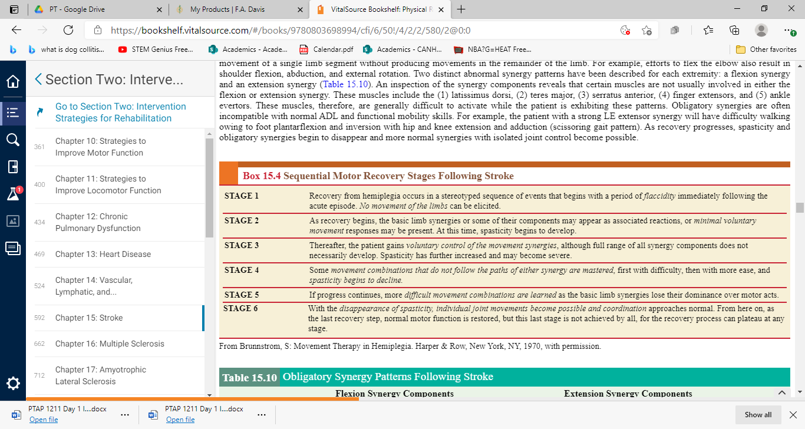

1. **Sensation Testing**

* 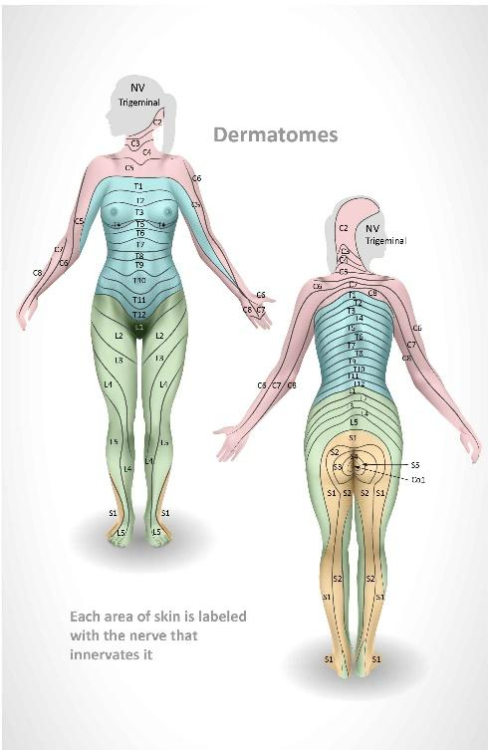
* Use light touch, sharp/dull, 2 point discrimination

1. **Proprioception/Kinesthesia**
   1. Proprioception: ask the patient if they can tell where the extremity is placed at the end of range
   2. Kinesthesia: ask the patient if they can tell which position the extremity is moving in
2. Synergy Pattern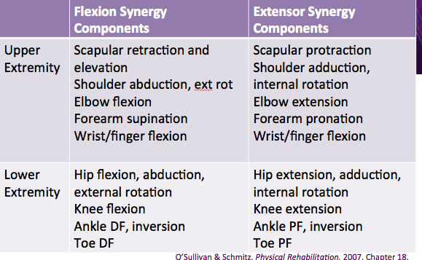

**References:**

[Dermatomes.jpg (2092×3217) (rcog.org.uk)](https://elearning.rcog.org.uk/sites/default/files/Obstetric%20analgesia%20and%20anaesthesia/Dermatomes.jpg)

O’Sullivan S. ( 2019 )*Physical Rehabilitation* 7th edition. FA Davis. Philadelphia PA.

[screen_shot_2015-06-02_at_80500_pm-14DB6BFB33F0F62FBD8.png (579×357)](https://s3.amazonaws.com/classconnection/863/flashcards/863/png/screen_shot_2015-06-02_at_80500_pm-14DB6BFB33F0F62FBD8.png)