### OT CVA Treatment Ideas and Progressions

Jen Thompson, MS, OTR/L

Begin by assessing the patient in functional self-care tasks and the initial steps of transfer, then grade activity to whole tasks and functional transfers/mobility. Progress to IADLs as appropriate. Regress and adjust treatment if necessary.

Also, educate patient / caregiver about principles of *neuroplasticity*, defined as the ability of the nervous system to respond to intrinsic or extrinsic stimuli by reorganizing its structure, function, and connections (Carey et al., 2019). These changes are associated with learning (Chang, 2014; Underleider, Doyon & Karni, 2002) and development from childbirth through the adult years (Greenhough, Black and Wallace, 1987). This information will be helpful to the patient, caregiver, and therapist that the majority of behavioral recovery, brain repair processes, and the rapid changes occur in the first weeks-to-months post stroke for most people. Thus, this timeline is crucial to maximize the potential of restorative interventions (Bernhardt et al., 2017).

1. **Cognition**- aspects of cognition are very enmeshed!

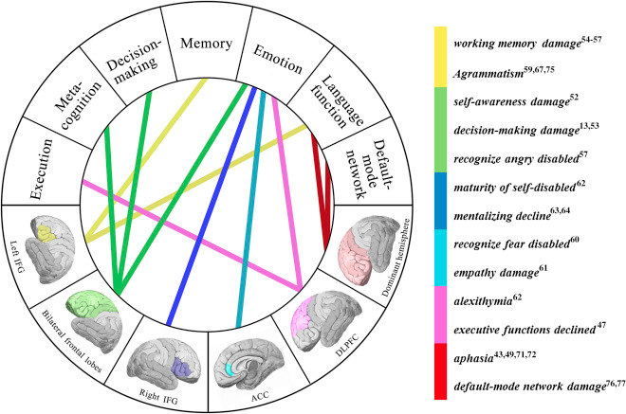

<https://www.sciencedirect.com/science/article/abs/pii/S1878875016300791>

* 1. Orientation
     1. Person (self), place (name and/or type of place [school, hospital, bus station], date of week, season/time of year, year, temporal (situational), location.
     2. Use visual cues (calendars, notebooks, newspapers, phone, anything with the date (month, day of the week, date, and year) and reinforce the date when you see them “Hi Mr. S, my name is ____ I’m here for your occupational therapy session. Today is _____. You are in the hospital, you had a stroke. You are here to get stronger.”
     3. Pictures can be helpful- orient patient to self, family, etc.
     4. Fade cues and visual reminders away until patient is more independently oriented.
  2. Direction following: progress from successfully following 1-step directions 100% → 2 step → multi-step as appropriate. Grade in a low stimulation environment first, then can progress to higher stimulation/ more distracting environments to assess quality and consistency of direction following. Many patients require very low stimulation, simple cuing at beginning of their rehabilitation.
  3. Initiation:
     1. Start with simple tasks - ADLs are typically best because these are familiar tasks that patient has done for many years (feeding, oral care, washing face, combing hair, applying deodorant, etc).
     2. Can the patient advocate for their own needs?
     3. Can the patient reach for a toothbrush when brought to the sink after being cued?
     4. Can the patient start washing hair, donning clothing, etc?
     5. Can the patient initiate a self-care routine without any cuing?
     6. Can the patient call the nurse for pain medication on his / her own?
     7. Eventually and as appropriate, progress the patient to a full ADL routine- gathering clothing and then donning their clothes, etc.
     8. Can integrate a home exercise program with weights here- if you demonstrate or provide a handout of exercises, assess if the patient can begin the exercises with/ without your cues, fade away as appropriate.
  4. Sequencing/ organization
     1. Again, start simple; progressing from ADL to IADLs as appropriate
     2. Work on simple 1 step tasks first (ex - combing hair, bringing cup to mough to drink, bringing fork loaded with food to mouth, placing hands on wheelchair armrest; taking cup out of a cabinet [in prep for hot beverage prep])
     3. Progress to 2-step task (ex- applying toothpaste to brush and brushing teeth, wetting wash cloth and washing face, cutting food; locking wheelchair brakes and scooting forward; turning on faucet and putting water in cup)
     4. Progress to multi-step task (ex- opening soap container, putting soap on washcloth, then washing face; opening cream and sugar, putting into coffee, stirring to mix; locking wheelchair brakes, scooting forward, and putting hands on wheelchair armrest in prep for transfer; full hot beverage prep task as appropriate, etc).
     5. Integrate other areas of cognition: medication management and sorting into a pill box, financial management and bill pay (in the US, balancing a checkbook and writing checks).
        1. Patients may ask about return to driving after stroke. As an OT in the US, I do not clear patients for return to driving tasks. I refer the patient to their neurologist for clearance.
     6. Incorporate leisure activities as patient improves: playing tabletop games or cards, sports activities (rule following, waiting your turn, etc), gardening, word searches, sewing, pet care as appropriate (open pet food, pour into bowl, place bowl in area that pet can reach, etc).
     7. If the patient is a parent- begin to incorporate child care activities (breastfeeding/ bottle feeding, holding baby, changing diaper, swaddling and dressing/undressing the child, putting the child into a car seat, etc)
        1. May need to consider adaptations to durable medical equipment: ex: securing a baby seat to a walker or rollator for transportation, etc, adaptive wedges or baby carriers, etc (Rodgers and Kirshbaum, 2014) .
     8. Tasks with less familiarity (pegs and cones) are not as functional and thus less appropriate than ADL / IADL tasks. Do your best to use functional activities that are directly related to the patient to improve recovery and maximize patient participation in therapies.
  5. Termination of task
     1. Is the patient able to stop washing face after he/she has bathed both cheeks, nose, forehead, ears, chin and neck; or do they perseverate on washing certain areas for an extensive period of time? Does the patient not shut off the faucet after filling up the cup (cup overflowing)
     2. Is the patient perseverating on tasks that should stop after a certain amount of time (ex: stop brushing teeth for more than 2 minutes, continue to apply deodorant after sufficient application)
  6. Attention to task
     1. How long is the patient able to pay attention to you or to the task? Seconds, minutes, 30 minutes+? Length of ADL session or just for the length of one task?
     2. Start the patient off in a low stimulation environment- no external distractions (completely turn off TV, radio, music, phone). Close the door, if possible. Ensure appropriate lighting (not too many bright lights).
     3. Minimize cues as best you can- recognizing that the patient may still need a lot of cues to successfully complete the task.
     4. Silence is okay!! Allot for extra time as needed.
     5. Gradually increase external stimulation as the patient is able to better attend and focus on the task. Typically I start out in the patient’s hospital room, and progress our sessions to a high stimulation hospital gym environment with a lot of external distractions.
  7. Consider aphasia, dysarthria, and oral-motor apraxia for accuracy in the patient’s communication→ consult SLP
  8. Assess safety awareness, insight, judgment and impulsivity.
     1. If the patient is impulsive, you may need to increase cuing to improve carryover and safety. This issue tends to arise the most when patients need to go to the bathroom, especially if the patient isn’t used to requiring assist for transfers as opposed to the ability to “get up and go” by themselves pre-hospitalization.
     2. This also looks at the patient’s executive function and higher level processing skills required for safe task completion.
     3. Is the patient able to independently call for help? May need signage around the patient’s room “stay in bed, ask for help to get up.”
     4. If the patient is transferring well and does not need physical assistance for self-care and transfers/ mobility routine, but lacks safety awareness and insight, the patient will require supervision at home to maximize safety. Therapist is responsible for evaluating the level of help available at home (caregivers, family, friends, etc) to ensure the patient is appropriately supervised. Family/ caregivers will require hands-on / in person training to develop skills in cuing and safety awareness.
     5. Consider medical alert buttons, door, bed or chair alarms,

1. Skin integrity and ability to weight shift independently
   1. Document with measurements and photos!
   2. Assess muscle strength, coordination, ability to recall directions to shift weight laterally and anteriorly/posteriorly in wheelchair (leaning, wheelchair pushup), or from supine<>sidelying left and right in bed.
   3. May need to use a checklist, clock, or alarm to remind the patient when it is time to shift weight and reposition.
   4. Consider use of wheelchair seating options (gel vs Roho air cushioning) as available to add an extra layer of cushioning.
2. Range of Motion/ Manual Muscle Testing
   1. Assess all joints and extremities, with exception for those with precautions or weight bearing restrictions.

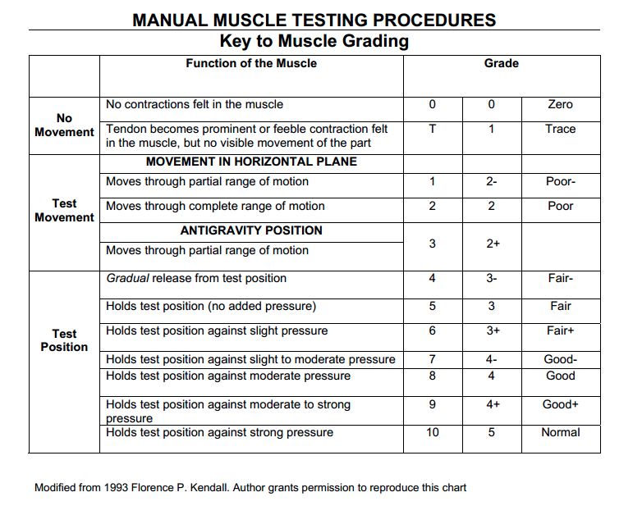

* 1. Document range of motion at all joints with goniometer, even if the patient has flaccidity or hemiparesis. As the patient progresses and motor cover returns, it is good to be able to document and identify the progression of recovery.
  2. Baseline knowledge required for range of motion:
     1. Landmarks and bony prominences
     2. Normal range of motion (ROM norms)
     3. Positioning of the patient
     4. Compensatory movements for ROM
     5. Goniometric placement and exact measurement technique
  3. See “ROM Evaluation Chart” in OT CVA Resources Folder for norms and positions!
  4. Consider splints if wrist/digit hemiparesis, flaccidity or hypertonicity for optimal positioning and skin integrity.
     1. Specialty courses and training often required for splinting.
     2. OT Splinting Examples: <https://www.youtube.com/watch?v=PvPFmiRoLWI>
     3. Resting Hand Splint: <https://www.youtube.com/watch?v=YCz5cmFIuOM>
     4. Forearm based Wrist Cock Up: <https://www.youtube.com/watch?v=jWTM7FmEB90> , <https://www.youtube.com/watch?v=X0YCgci3Xc8> , and <https://www.youtube.com/watch?v=ohtBwMWop0Q>
     5. Patient to wear splint as tolerated, remove every shift / q4 / q2 depending on patient’s skin integrity and cognition, ability to don/doff, etc. If patient’s cognition is impaired, patient may require cues and/or assist to doff/don splint and perform skin check), discontinue use.
  5. Consider use of Fugl-Meyer assessment to evaluate the patient’s ROM/strength at the beginning and end of patient care.

1. Hand strength, dexterity and coordination
   1. If you have dynamometric testing materials available, use these at evaluation and discharge for grip and pinch strength.
   2. Look at opposition, both the patient’s accuracy and speed.
   3. Pinch/ grip strength
      1. 9 Hole Peg Test: <https://www.youtube.com/watch?v=JaGX-ji9eMA>
      2. Box and Blocks: <https://www.youtube.com/watch?v=8nsn91JFYgE>
      3. Jebson Taylor Hand Function Test: <https://www.youtube.com/watch?v=KjHG2dW96jU>
   4. Identify range of motion and strength deficits (is weakness specific to shoulder? Elbow? Wrist? Digits?) and use this to guide your treatments.
   5. Ideas for ADLs: grasping toothbrush, comb, feeding utensils, grasping/holding clothing and hiking up over hips, wiping after toileting, adaptive equipment to assist in getting dressed, tying shoelaces
      1. Use built up handles, or can wrap pencils/ utensils in tape to make the handles thicker to help improve patient’s grasp if it is weak.
   6. Ideas for IADLs: grasp on pencil/pen for check-writing task, making grocery list, changing lightbulbs, household maintenance, folding laundry, opening cans/containers, opening medication bottles, holding broom/vacuum, sorting medication into a pillbow, etc.
   7. Ideas for leisure activities: playing instruments, card or board games, coloring, holding a book or tablet for reading, typing, computer games, gardening, operating remote controls/ video game controls, crafts, etc.
2. Proprioception
   1. Rostral (dorsal, posterior) spinocerebellar tract; Golgi tendon organs
   2. Importance for balance, postural control, motor learning and error detection/correction.
   3. Weightbearing, mirror, proprioceptive wrapping during functional mobility tasks

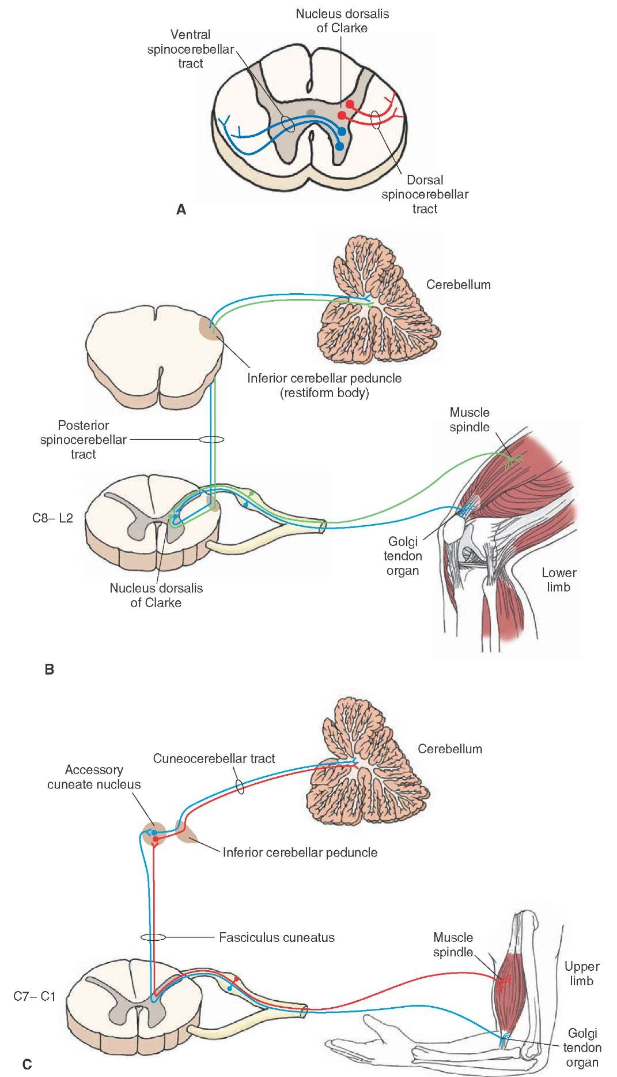

http://what-when-how.com/neuroscience/the-cerebellum-motor-systems-part-1/

1. Sensation: sharp/dull, hot/cold
   1. Assess across all dermatomes to better isolate any areas of sensation deficit

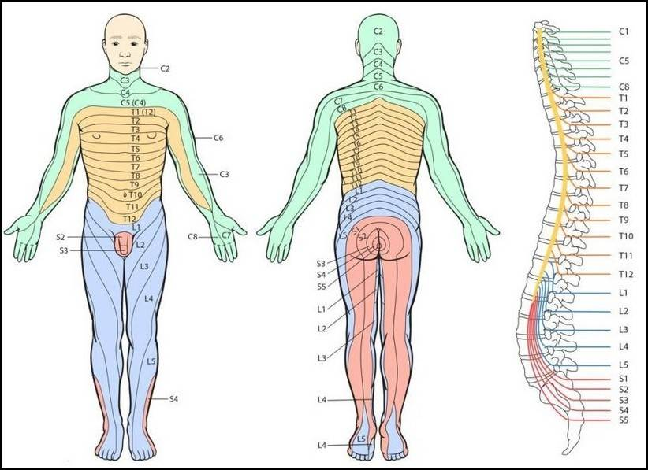

<https://bonesmart.org/forum/threads/dermatome-map-for-spinal-pain.13737/>

* 1. Make sure the patient has appropriate sensation for temperature and sharpness- this directly relates to safety with water temperature for ADLs, cooking/ IADL tasks, etc. Oven mitts, gardening gloves, etc are good protection for these activities but should be used with caution.
  2. Can test with Semmes-Weinstein: <https://www.youtube.com/watch?v=xNzWF6XS8FI>
  3. May need to associate temperatures with visual cues for safe ADLs(hot = bad (sad face) or other types of feedback to reduce risk of burns or personal injury.
     1. If cognition is impaired, patients will require assist from caregiver to assist in determining appropriate temperature.

1. Motor Recovery
   1. Functional electrical stimulation - MUST BE ORDERED BY MD. Contraindications to electrical stimulation: history of cancer, implantable devices (pacemakers, spinal cord or deep brain stimulator, etc), impaired skin integrity, impaired sensation (patient needs to be able to communicate to the therapist if the stimulation is too strong- can’t rely just on facial grimaces or gestures).
      1. What is Functional Electrical Stimulation (General explanation): <https://www.youtube.com/watch?v=iR8SAETKZVs>
      2. Using e-stim to promote motor recovery: <https://www.youtube.com/watch?v=iDEgN7bTuKc> ; <https://www.youtube.com/watch?v=s516torEQrY>;
      3. Using e-stim to reduce spasticity: <https://www.youtube.com/watch?v=glo5WR3-oH8>
   2. Mirror therapy: “tricks” the brain into thinking the impaired limb is actually intact
      1. <https://www.youtube.com/watch?v=1BnsQO7a4Og> ; <https://www.youtube.com/watch?v=kc7OiOBv-t0>
      2. Limited effect for patients with cognitive impairment - this concept is abstract and can be difficult to grasp if a patient doesn’t comprehend why this therapy works!
   3. Kinesiotaping and leukotaping for improved position of joint (specifically shoulder for shoulder subluxation) as well as weightbearing on tabletop to maximize joint stability.
2. Vision
   1. Check oculomotor control, pupil alignment; smooth pursuits, saccades, nystagmus. Most common in R hemisphere CVAs.
   2. Assess with visual tracking task: draw large “X” and “H” in the air while facing patient, assess how the patient tracks and if they lose tracking during the test.
      1. Visual Neglect/ Inattention: patient doesn’t attend to hemiparetic arm/leg or environment, but is able to see in all fields of vision.
         1. Typically presents during ADL/transfers tasks: forgets to dress one arm, bumps into a wall while walking, etc.
         2. Cues and visual strategies to attend to one side:
            1. Anchors: use strip of bright tape on the edge of a surface or object to assist the patient in looking all the way over.
            2. Lighthouse strategy: additional scanning strategies with the image of a lighthouse” looking all the way left, all the way right <https://www.youtube.com/watch?v=X8-UjrE6VUc>
            3. Head turns: turn head all the way to the left and then direct eyes down
      2. Homonymous hemianopsia- visual field loss in the **same side of both eyes**
         1. Due to lesions in various portions of the optic tract- patient is not “blind” but lacks vision in a particular field of vision (impaired visual processing).
         2. Results from an interruption in optic tract, optic chiasm, lateral geniculate nucleus, optic radiations, and/ or primary visual cortex (Donnolly, 2011).
      3. Patients can have neglect without hemianopsia, hemianopsia without neglect, and neglect with hemianopsia.
         1. Basic testing: Star Cancellation Test, Line Bisection Test
         2. Integration of Optometrist for additional testing and diagnosis.

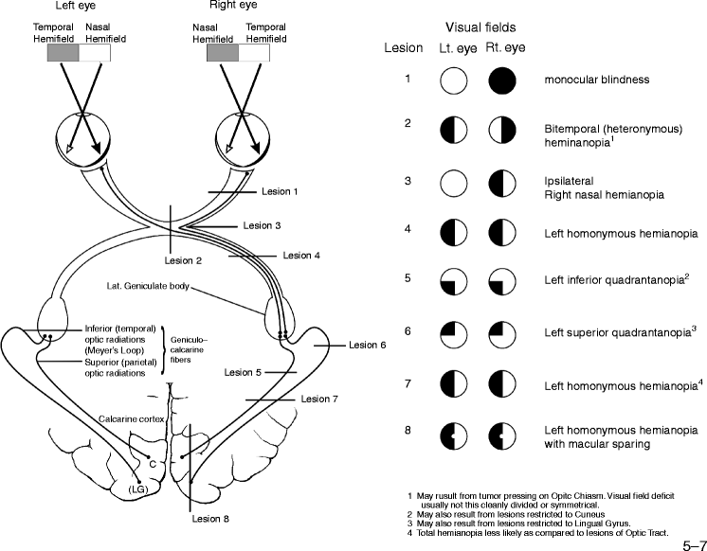

https://link.springer.com/referenceworkentry/10.1007%2F978-0-387-79948-3_739

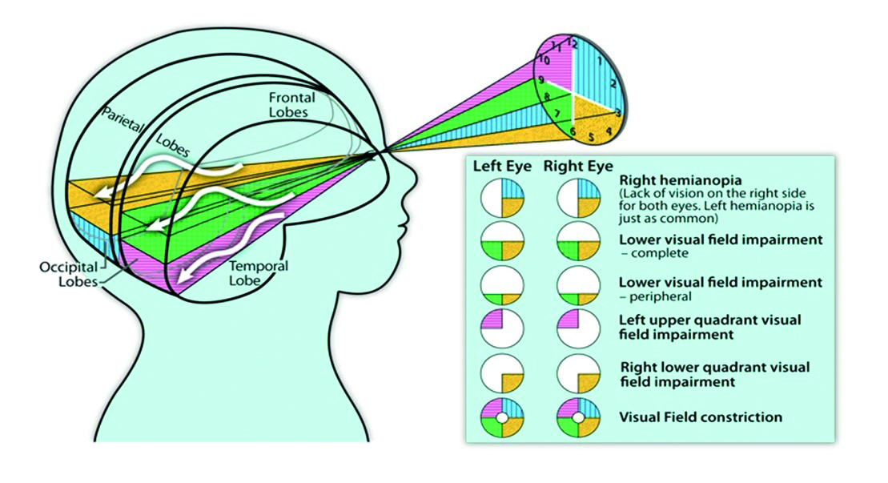

https://www.opticianonline.net/cet-archive/5785

9. Balance: Is the patient leaning towards one side or the other? Does the patient recognize deviation from midline?

1. Seated
2. Standing (only if standing is safe)
3. See Balance treatment ideas in resource folder for ideas!

10. Vitals management

1. Assess Blood pressure, oxygen saturation, heart rate in supine → sitting → standing (if safe to do so)
2. If blood pressure is low, the patient may need compression stockings to feet and abdominal binder to trunk to increase BP.
3. May need to get a respiratory therapist involved if the patient demonstrates shortness of breath or respiratory distress during sessions. Some facilities allow therapists to titrate (adjust) amount of supplemental oxygen during the sesion to accommodate the patient’s needs, however other facilities do not- check with MD.

**References**

Bernhardt et al. (2017). Agreed definitions and a shared vision for new standards in stroke recovery research: The stroke recovery and rehabilitation roundtable taskforce. *Neurorehabilitation and Neural Repair*, 31(9), 793–799. doi: 10.1177/1747493017711816

Chang (2014). Reorganization and plastic changes of the human brain associated with skill learning and expertise. *Frontiers in Human Neuroscience*, 8. [doi:10.3389/fnhum.2014.00035](https://doi.org/10.3389/fnhum.2014.00035)

Donnelly K. (2011) Homonymous Hemianopsia. In: Kreutzer J.S., DeLuca J., Caplan B. (eds) Encyclopedia of Clinical Neuropsychology. Springer, New York, NY. <https://doi.org/10.1007/978-0-387-79948-3_739>

Greenough, Black, & Wallace. (1987). Experience and brain development. *Child Development*, *58 (3),*  pp. 539–559. doi: 10.2307/1130197

Hughes, Tommasino, Budhota & Campolo (2015). Upper extremity proprioception in healthy aging and stroke populations, and the effects of therapist- and robot-based rehabilitation therapies on proprioceptive function. *Frontiers in Human Neuroscience, 9.* doi: 10.3389/fnhum.2015.00120

Rodgers and Kirshbaum (2014). Parenting after stroke. In Stroke Rehabilitation: A function based approach (4th edition).

Ungerleider, Doyon, & Karni. (2002). Imaging brain plasticity during motor skill learning. *Neurobiology of Learning and Memory*, 78(3), 553–564. [doi:10.1006/nlme.2002.4091](https://doi.org/10.1006/nlme.2002.4091)