### Cerebrovascular Accident- CVA (Stroke): OT Evaluation

Jen Thompson, MS, OTR/L

**Functional Areas of the Cerebellar Cortex**

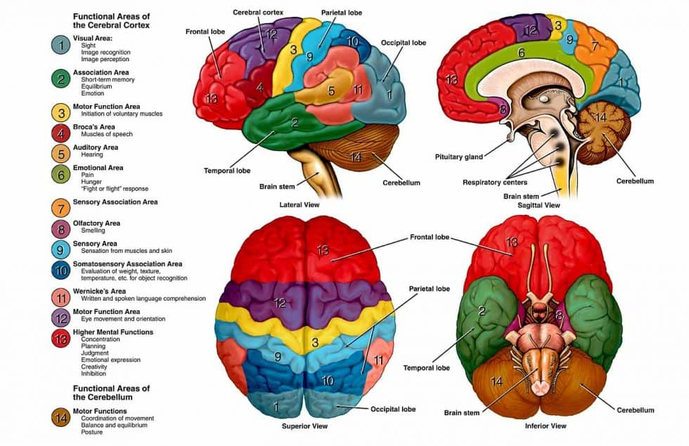

<https://bodymindandbrain.com.au/huh-what-does-my-brain-have-to-do-with-it/>

**Perform a thorough chart review, including orders from MD and surgeon.**

1. Type of CVA, artery/ location, etiology (cause) of CVA
2. Comorbidities and other pre-existing medical conditions that may impact patient care and approach.
3. Other precautions if the patient has polytrauma?
   * 1. Surgical precautions: Spinal, sternal, bone flap, craniotomy/ craniectomy, anterior/posterior/global hip precautions
     2. Blood pressure parameters
     3. Weight bearing restrictions
     4. Bracing, splint, or casts orders: on at all times, can the brace be removed for showers or skin checks, etc
4. Additional things to be aware of: lines, drains, tubing, IVs, wounds, orders to keep head of bed elevated to reduce aspiration risk, etc.

**OT: Begin evaluation.**

Introduce yourself and your role in the patient’s care. Throughout evaluation, explain what you are doing and why you are doing it - this helps to build therapeutic rapport and trust between patient and therapist.

Before transferring the patient, complete their occupational profile / chart review:

1. Confirm name, birthday and medical record number.
2. Determine the patient's preferred name (nickname?) and preferred pronouns.
3. Before hospital admission, what was the patient’s prior level of function?
   1. Independent in ADL/IADL routine? Was the patient active or sedentary at baseline?
   2. What area/town do they live in?
   3. Who does the patient live with (alone, spouse/partner, siblings, pets)?
      1. If the patient has someone at home, what is the ability of that person to assist? Are they willing and able to assist the patient bathe, get dressed, etc if needed*?* Can the caregiver provide physical assist for transfers if needed? *\*\*\*\* this is crucial because if the patient lives alone or does not have appropriate help, this may affect discharge plan (need to hire private caregivers, go to another rehab facility, etc).*
      2. Assist in transporting patients to doctors appts?
      3. Assist / perform IADLs: grocery stores, picking up prescriptions, doing laundry, etc
   4. Does the patient have to provide caregiver assistance to any or their family members (aging parents, children, other relatives?)
   5. Was the patient working, attending school, raising family, etc.
   6. Determine daily routine (does the patient wake up early? Shower in the morning or at night? Responsible for transporting children to school? Etc).
   7. Identify leisure activities
   8. What is the home setup like?
      1. Stairs and railings:
      2. How many stairs to enter the home?
      3. Are there railings on the steps?
      4. Is there ramp access to the home?
      5. If the patient lives in a 2- story home, are there railings to go up the stairs?
      6. Describe your bathroom:
         * 1. Does the patient have a bathroom on the first/ main floor of the home?
           2. Does the bathroom have just a toilet, or does it have a place to bathe as well?
           3. Is the shower setup a shower stall (stand up shower with small step usually 2-4” to step over), or a tub/ shower combo unit (have to step over the tub to get into the shower)? Stand alone tub?
           4. Is there a seat to sit on in the shower?
           5. Are there grab bars in the shower or next to the toilet?

Vii. Describe your kitchen?

* + - * 1. Style of kitchen- small, open, galley? Is there a table to negotiate around?
        2. Can you access your kitchen with a wheelchair or walker if needed?

Other areas to assess on evaluation:

1. Identify level of pain: acute pain, incisional pain at any coinciding surgical sites, chronic pain that may contribute to patient’s recovery?
2. Evaluate cognition
   1. Direction following: does the person most consistently follow 1, 2, or complex commands? Do they need multimodal cues or visual aides to complete the task? Low stimulation environment required?
   2. Initiation
   3. Sequencing/ organization
   4. Termination of task
   5. Attention to task
   6. Orientation
   7. Consider aphasia, dysarthria, oral-motor apraxia→ consult SLP
   8. Can the patient advocate for themselves and their needs (toileting, repositioning, pain management?)
   9. Assessments:
      1. Oral component: Brief Interview of Mental Status (BIMS), Montreal Cognitive Assessment (MoCA)
      2. Non-Oral based assessments: Non-Language-Based Cognitive Assessment, Aphasia Check List
3. Assess safety awareness, insight, judgment and impulsivity
4. Skin integrity and ability to weightshift independently
5. Evaluate range of motion and manual muscle testing- all joints and extremities, with exception for those with precautions or weight bearing restrictions
   1. Document even if the patient has flaciddity or hemiparesis- as patient progresses and motor cover returns, it is good to be able to document and identify the progression of recovery.
6. Hand strength, dexterity and coordination
   1. Consider formal testing as appropriate: Box and Blocks, 9 Hole Peg Testing
   2. Opposition, finger to nose- accurate? Dysmetric- over or under shooting?
7. Proprioception
8. Sensation: sharp/dull, hot/cold
9. Motor planning- Include dysdiadochokinesia assessment (rapid alternating supination/pronation) for motor planning
10. Vision (perform visual screen)
    1. Has the patient's vision changed since their hospital admission?
    2. Check oculomotor control, pupil alignment; smooth pursuits,saccades, nystagmus
       1. Neglect, inattention, hemianopsia
11. Balance, seated vs standing (only if standing is safe)- is patient leaning towards one side or the other? Does the patient recognize deviation from midline?
12. Vitals management

*if the patient has expressive/ receptive aphasia, impaired attention, decreased cognition, and/or is a poor historian, you will need to confirm prior level of function and home setup with the patient’s family and/or caregiver to ensure accuracy.

**OT: Self-Care areas to assess**

* Document how much the patient is doing, and level/ type of assist you have to provide). Also include areas of deficits as noted (vision, strength, range of motion, sensation, proprioception, cog deficits, balance difficulties, hemiparesis, etc).

i. Grooming: ability to pick up and sustain grasp on ADL items. Ability to wash face, brush teeth/ applying retainers or dentures if appropriate, hair care (combing, washing, blow drying and/ or styling hair), apply makeup if the patient finds this meaningful, put in contacts or don glasses.

ii. Feeding: ability to pick up and sustain appropriate grasp on utensils during meals; ability to cut, spear or scoop, and accurately bring food to mouth. Ability to pick up cup and accurately bring to mouth. Ability to locate all items on plate (vision).

1. OTs assess the patient’s ability to bring food/ drink to the mouth. SLP assesses the quality of lip seal and swallow for both liquids and solids. SLP determines diet texture and swallow strategies. Stay within your scope of practice and contact SLP with any questions or concerns related to patient aspiration, coughing or difficulty swallowing.

Iii. Bathing: Document upper body bathing (above the pelvis) and lower body bathing (below through pelvis) separately. Ability to pick up and sustain grasp on washcloth / soap. Ability to reach and thoroughly bathe upper body and lower body. Ensure bathing includes underneath arms, anterior and posterior perihygiene, and below knees/ feet.

iv. Dressing: Document upper body dressing (above the pelvis) and lower body bathing (below through pelvis) separately. This includes undergarments, socks and shoes including tying shoes. This also includes any required bracing (slings, casts, etc). Ability to pick up and sustain grasp on clothing.

v. Toileting routine (use assistive device in collaboration with physical therapist):

1. Toilet transfer: ability to get onto and off toilet and/or commode. This can take place at the bedside or in the bathroom, depending on the patient’s transfer ability. For particularly complex patients or those in the very early stages of recovery, toileting may need to be done at bedlevel for safety.
2. Toilet hygiene: ability to perform perihygiene after voiding or having a bowel movement.
3. Clothing management: ability to bring pants / undergarments down (dehike) hips before toileting, and up over (hike) the hips after toileting.

* Make sure to note the patient's center of gravity and base of support- can they correct any loss of balance on their own?

References

Bartels, Duffy, and Beland. (2016). Pathophysiology, medical management and acute rehabilitation of stroke survivors, 1-45. In G. Gillen, Stroke Rehabilitation: A function based approach. Elsevier Publishers.

Kalbe, Reinhold, Brand, Markowitsch, & Kessler. (2005). A new test battery to assess aphasic disturbances and associated cognitive dysfunctions -- German normative data on the aphasia check list. *Journal of Clinical Experimental Neuropsychology., 27*(7), 779-94. Retrieved from https://pubmed.ncbi.nlm.nih.gov/16183613/

Mayo Clinic. Brain aneurysm. Accessed on 3/12/2021 from <https://www.mayoclinic.org/diseases-conditions/brain-aneurysm/symptoms-causes/syc-20361483>

Neada, D. (2017). Brief Interview for Mental Status. Accessed on 3/21/2021from <https://www.mdapp.co/brief-interview-for-mental-status-bims-calculator-206/>

Netter, F. 2014. Atlas of Human Anatomy (6th Ed.) Plate 141. Elsever Publishers, Philadelphia PA.

Neurotherapy Practice Gold Coast. Huh? What does my brian have to do with it. Accessed on 3/12/2021 from <https://bodymindandbrain.com.au/huh-what-does-my-brain-have-to-do-with-it/>

Stroke Awareness Foundation. Stroke Facts and Statistics. Accessed on 3/12/2021 from <https://www.strokeinfo.org/stroke-facts-statistics/>

Wu, Lyu, Liu, Li, & Wang. (2017). Development and standardization of a new cognitive assessment test battery for Chinese aphasic patients: A preliminary study. *Chinese Medical Journal, 130* (19), 2283-2290. doi: 10.4103/0366-6999.215326